Dark Matters Astro Program Schedule
- 4.00 P. M. Arrival - Introduction
- 4.30 P. M Observation of the Sun starts
- 5:00 P. M. to 5.30 P.M Viewing the Sun
- 5.30 P. M. to 6.00 P. M Participants will be shown the Telescopes and other
instruments in the observatory and their functions and features will be explained.
- 6:00 P.M. to 7:00 P.M Lecture on Astronomy
- 7.00 P.M Observation begins
Every object that we will show has been selected for that night and planned.
People/Students will first observe an object with their naked eye and then the same object will be projected onto the big screen along with a description of the object.
- 9:00 P.M to 10:00 P.M Dinner break
- 10:00 P.M Observation begins and continues past midnight
- 8:00 to 9.30 AM Viewing the Sun, Breakfast and departure
We are open to ideas, suggestions and willing to adapt and change our program. A customized itinerary can be planned if necessary.
Our instruments are professional grade and world class.
Following are some of the images that we view and project onto the big screen. This is all done in
real time:

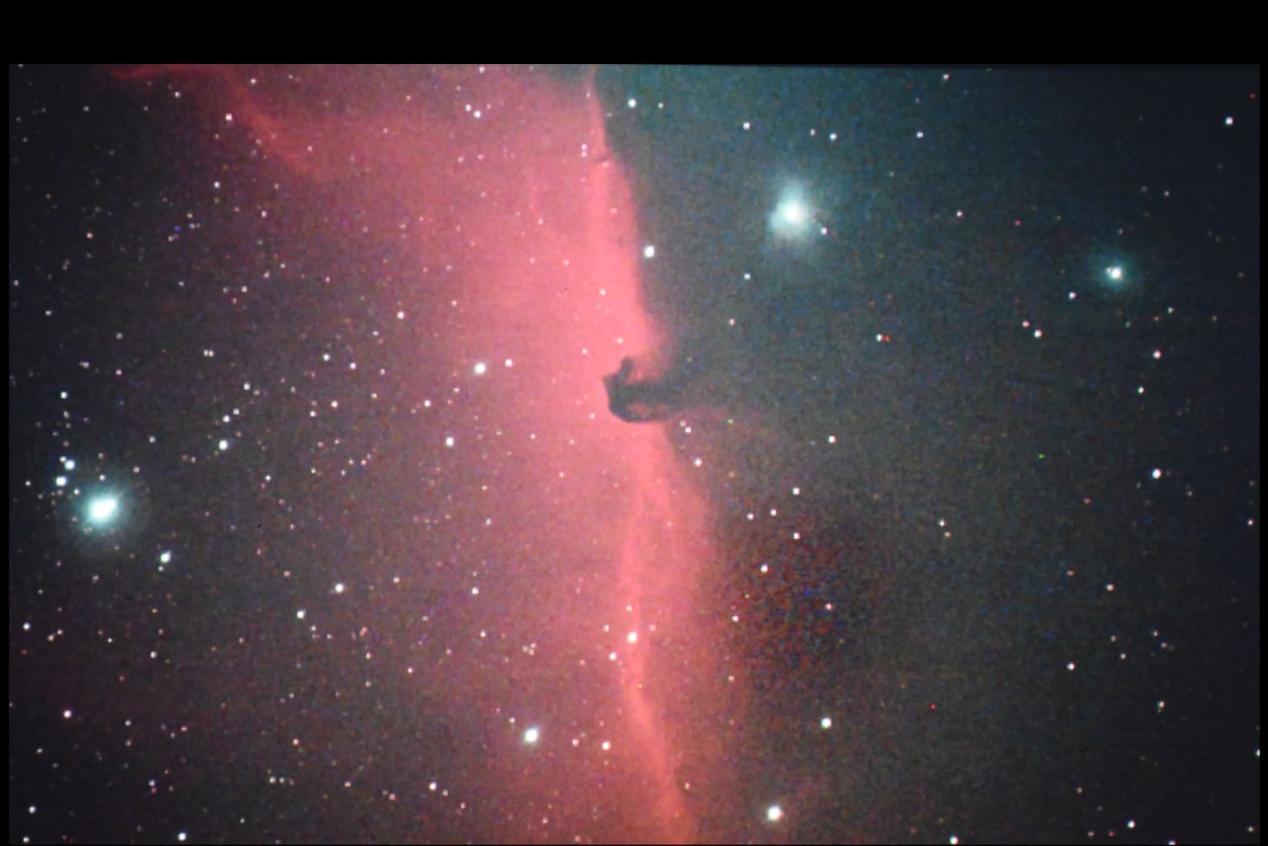
Horsehead Nebula

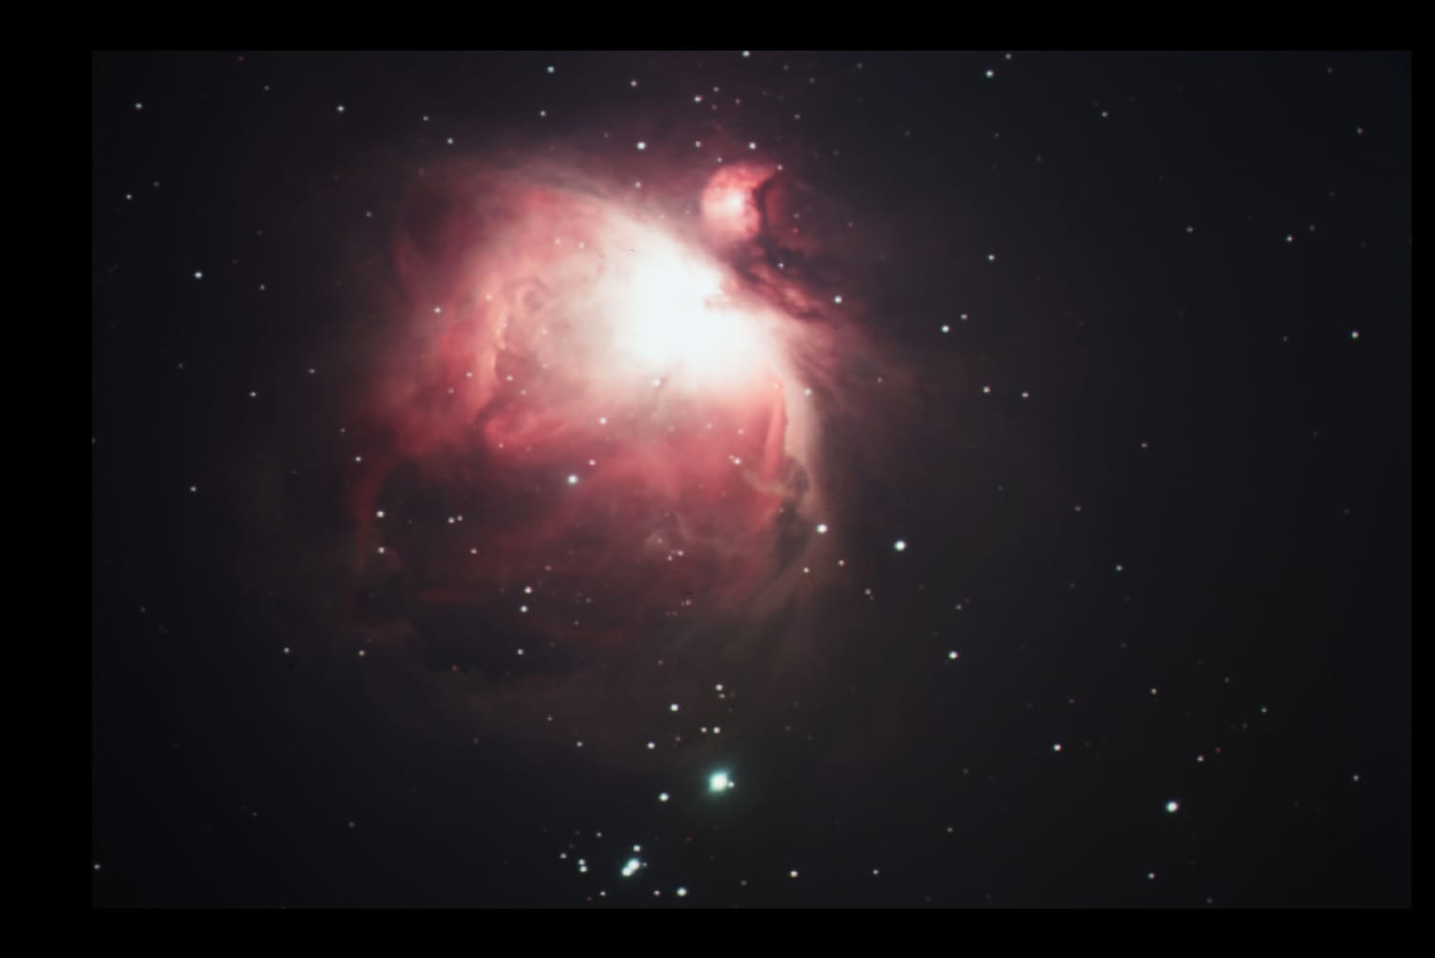
Orion Nebula

Typical Observing or observation sessions below: